**GROUP:** 13

**GROUP MEMBERS**:

* ID - 201914025, Saidur Rahaman Sagor
* ID - 202014038, Muhammad Samee Sevas
* ID - 202014050, Shejuti Binte Feroz

**Project Name:** Digital Metal Detector

**Objective:**

The objective of this project is to detect the presence of metal nearby. For finding metal inclusions hidden within objects, or metal object buried underground is the main motto of this project. They often consist of a handheld unit with a sensor probe which can be swept over the ground or other objects.

**Description:**

Metal Detector is a security device which is used for detecting metals which can be harmful, at various places like Airports, shopping malls, cinemas, etc. We are building the **Metal Detector using Arduino**. In this project, we are going to use a coil and capacitor which will be responsible for the detection of metals. Here we have used an **Arduino UNO** to build this **metal detector project**. Wherever this detector detects any metal near it, the buzzer starts beeping very rapidly. Whenever some current passes through the coil, it generates a magnetic field around it. And the change in the magnetic field generates an electric field. Now according to Faraday's law, because of this Electric field, a voltage develops across the coil which opposes the change in magnetic field and that’s how Coil develops the **Inductance**, means the generated voltage opposes the increase in the current. When any metal comes near to the coil then coil changes its inductance. This change in inductance depends upon the metal type. It decreases for non-magnetic metal and increases for ferromagnetic materials like iron.

Depending on the core of the coil, inductance value changes drastically. In the figure below you can see the air-cored inductors, in **these inductors, there will be no solid core**. They are basically coils left in the air. The medium of flow of magnetic field generated by the inductor is nothing or air. These inductors have inductances of very less value. These inductors are used when the need for values of few microHenry. For values greater than few milliHenry these are not a suitable one. In below figure you can see **an inductor with ferrite core**. These Ferrite Core inductor has very large inductance value. the coil wound here is a air-cored one, so when a metal piece is brought near the coil, the metal piece acts as a core for the air cored inductor. By this metal acting as a core, the inductance of the coil changes or increases considerably. With this sudden increase in inductance of coil the overall reactance or impedance of the LC circuit changes by a considerable amount when compared without the metal piece.

So here in this **Arduino Metal Detector Project**, we have to find the inductance of the coil to detect metals. So to do this we have used LR circuit (Resistor-Inductor Circuit) that we already mentioned. Here in this circuit, we have used a coil having around 20 turns or winding with a 10cm diameter. We have used an **empty tape roll and wind the wire around it to make the coil**.

**Components:**

* Arduino UNO and Cable
* Copper coil
* 1N4148 diode
* 10nf capacitor
* Buzzer
* Led
* 1k ohm & 330 Ohm Resistor
* Jumper wires and a breadboard
* 9v Battery and Cable

|  |  |  |
| --- | --- | --- |
| **Item No** | **Components name with model number** | **Amount** |
| 1 | Arduino UNO and Cable | 1+1 |
| 2 | 5M Copper coil | 20gm |
| 3 | 1N4148 diode | 1 |
| 4 | 10nf capacitor | 1 |
| 5 | Buzzer | 1 |
| 6 | Red Led | 1 |
| 7 | 1k ohm & 330 Ohm Resistor | 1+1 |
| 8 | Jumper wires and a breadboard | 15+1 |
| 9 | 9v Battery and Cable | 1+1 |

**Methodology:**

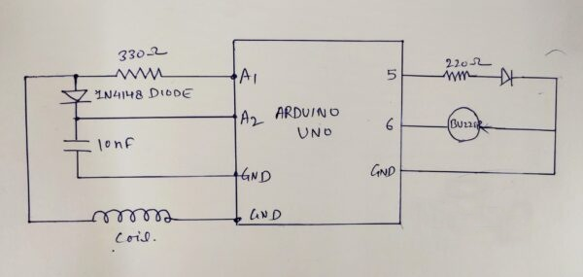

Fig: Block Diagram

As should be obvious there are three things which are utilizing to finish the entire task. Electronic circuit, Arduino and copper curl. Here really we are making a nearness sensor that identifies the metal with the assistance of the RC, the circuit worked in the Electronics part. Presently when we take this venture close to the metal it detects the metal close to it because of the electromagnetic waves transmitted from the loop. Thus with these electromagnetic waves, the circuit imparts a sign to the Arduino. Arduino looks at and forms the information and sends the guidance to the signal and the LED by the code. The curl will produce the electromagnetic waves and when we take it close to the metal the electromagnetic waves get twisted. What's more, Arduino gives the guidance as per every one of these information varieties.

At whatever point some present experiences the circle, it creates an attractive field around it. Besides, the modification in the attractive field delivers an electric field. By and by according to Faraday's law, because of this Electric field, a voltage makes over the twist which negates the modification in an alluring field and that is the manner in which Coil develops the Inductance, which infers the delivered voltage confines the extension in the stream. This is the simplest metal indicator venture The unit of Inductance is Henry and condition to evaluate the Inductance is:

**L = (μο * N2 * A) / l**

Where, L- Inductance in Henries

μο- Permeability,

its 4π*10-7 for Air

N- Number of turns

A- Inner Core Area (πr2) in m2 l-

Length of the Coil in meters

**Outcome:**

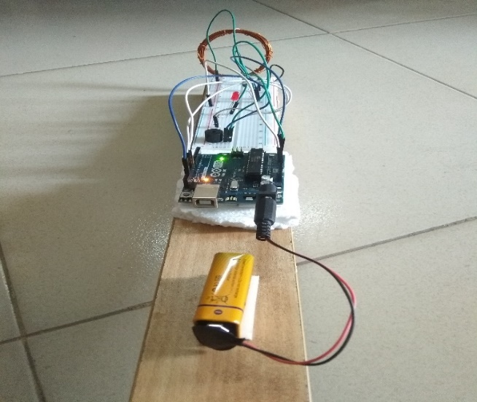 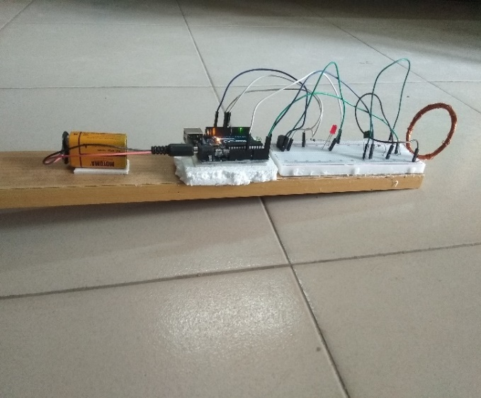

Fig: Digital Metal Detector Project

**Contribution:**

1. **ID - 201914025, Saidur Rahaman Sagor :** Buying Components, help to make the project.
2. **ID - 202014038, Muhammad Samee Sevas :** Writing code , Presentation of the project, fixing errors, connecting the circuit.
3. **ID - 202014050, Shejuti Binte Feroz :** Writing code ,Writing Report fixing errors, connecting the circuit.